Mobile Network - Core Network

🧠 What Is a Core Network?
# Source: AI Source: Provided by: [Data Path: Persons Table -> ID Column: 1, Name_En Column: Motasem Essam] -> From: [ChatGPT] on [1/23/2026]
The Core Network (also called the backbone of a telecommunications system) is the central part of a mobile or internet network. It connects the access part of the network (cell towers, Wi-Fi points) to other networks (like the internet, landlines, or other mobile users).
Think of the core network as the “central brain” that manages all routing, switching, authentication, billing, and communication between users and the world.

Core Network Image
# Source: Table Source: Provided by: [Data Path: Persons Table -> ID Column: 1, Name_En Column: Motasem Essam] From: [Data Path: Miscellaneous Folder -> Miscellaneous Database -> Miscellaneous Table -> ID: 33] on [1/23/2026]
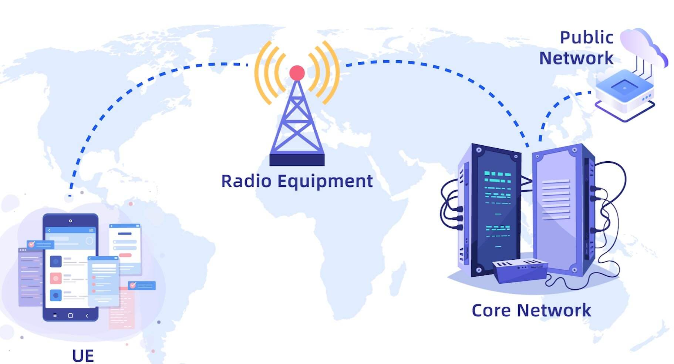

🧩 What Does the Core Network Do?
# Source: AI Source: Provided by: [Data Path: Persons Table -> ID Column: 1, Name_En Column: Motasem Essam] -> From: [ChatGPT] on [1/23/2026]
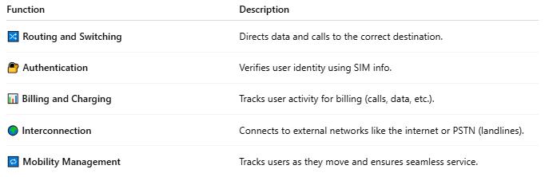

Function | Description
🔀 Routing and Switching | Directs data and calls to the correct destination.
🔐 Authentication | Verifies user identity using SIM info.
📊 Billing and Charging | Tracks user activity for billing (calls, data, etc.).
🌍 Interconnection | Connects to external networks like the internet or PSTN (landlines).
🔁 Mobility Management | Tracks users as they move and ensures seamless service.

🧱 Components of a Core Network:

📞 In Mobile Networks (e.g. 4G/5G):
# Source: AI Source: Provided by: [Data Path: Persons Table -> ID Column: 1, Name_En Column: Motasem Essam] -> From: [ChatGPT] on [1/23/2026]
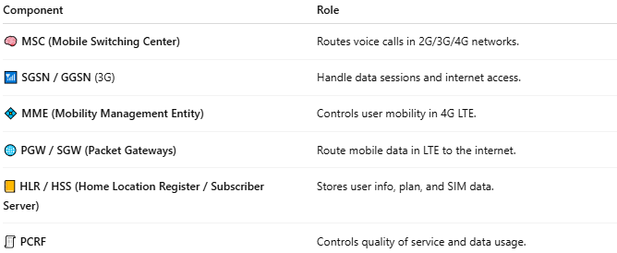

Component | Role
🧠 MSC (Mobile Switching Center) | Routes voice calls in 2G/3G/4G networks.
📶 SGSN / GGSN (3G) | Handle data sessions and internet access.
💠 MME (Mobility Management Entity) | Controls user mobility in 4G LTE.
🌐 PGW / SGW (Packet Gateways) | Route mobile data in LTE to the internet.
📒 HLR / HSS (Home Location Register / Subscriber Server) | Stores user info, plan, and SIM data.
🧾 PCRF | Controls quality of service and data usage.

🛰️ In Internet Service Providers (ISPs):
# Source: AI Source: Provided by: [Data Path: Persons Table -> ID Column: 1, Name_En Column: Motasem Essam] -> From: [ChatGPT] on [1/23/2026]
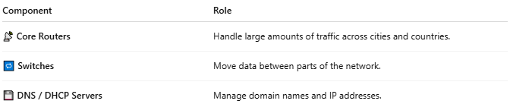

Component | Role
📡 Core Routers | Handle large amounts of traffic across cities and countries.
🔁 Switches | Move data between parts of the network.
💾 DNS / DHCP Servers | Manage domain names and IP addresses.

📡 Example Flow (Making a Phone Call):
# Source: AI Source: Provided by: [Data Path: Persons Table -> ID Column: 1, Name_En Column: Motasem Essam] -> From: [ChatGPT] on [1/23/2026]
- 📱 Your phone sends a call to a cell tower.
- 🗼 The tower sends it to the core network via the BSC/MSC.
- 🧠 The core network routes the call to another mobile user, landline, or VoIP system.
- 🔁 If you're moving, the core handles handover and session continuity.

Core Network vs Backhaul
# Source: AI Source: Provided by: [Data Path: Persons Table -> ID Column: 1, Name_En Column: Motasem Essam] -> From: [ChatGPT] on [1/23/2026]
Both the Core Network and Backhaul are essential parts of a mobile or telecom system, but they play different roles in how your phone connects to the internet or makes calls.
📊 Comparison Table
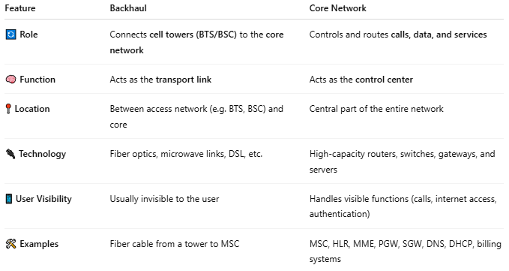

Feature | Backhaul | Core Network
🔄 Role | Connects cell towers (BTS/BSC) to the core network | Controls and routes calls, data, and services
🧠 Function | Acts as the transport link | Acts as the control center
📍 Location | Between access network (e.g. BTS, BSC) and core | Central part of the entire network
🔌 Technology | Fiber optics, microwave links, DSL, etc. | High-capacity routers, switches, gateways, and servers
📱 User Visibility | Usually invisible to the user | Handles visible functions (calls, internet access, authentication)
🛠️ Examples | Fiber cable from a tower to MSC | MSC, HLR, MME, PGW, SGW, DNS, DHCP, billing systems

📡 Example: Mobile Phone Using the Network
# Source: AI Source: Provided by: [Data Path: Persons Table -> ID Column: 1, Name_En Column: Motasem Essam] -> From: [ChatGPT] on [1/23/2026]
- Phone connects to a nearby BTS (cell tower).
- Signal is sent via the backhaul to the Core Network.
- The Core Network:
  - Checks who you are (authentication),
  - Routes your call or data request,
  - Connects you to the internet or another phone.

🧠 Think of It Like a Highway System:
# Source: AI Source: Provided by: [Data Path: Persons Table -> ID Column: 1, Name_En Column: Motasem Essam] -> From: [ChatGPT] on [1/23/2026]
- Backhaul = Roads from towns (cell towers) to the big city (core).
- Core Network = The city center where decisions are made: traffic control, communication, routing.

📖 Summary:
# Source: AI Source: Provided by: [Data Path: Persons Table -> ID Column: 1, Name_En Column: Motasem Essam] -> From: [ChatGPT] on [1/23/2026]
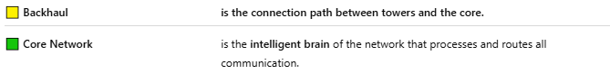
🟨 Backhaul | is the connection path between towers and the core.
🟩 Core Network | is the intelligent brain of the network that processes and routes all communication.

📖 Summary:
# Source: AI Source: Provided by: [Data Path: Persons Table -> ID Column: 1, Name_En Column: Motasem Essam] -> From: [ChatGPT] on [1/23/2026]
The core network is the central control system of telecom infrastructure. It manages how voice, data, and messages move through the system, connects users to each other and to the internet, and ensures everything is secure, fast, and reliable.

